Renju lesson on November 22, 2001
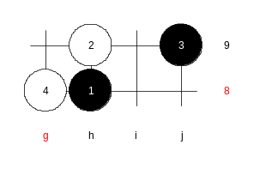
Hello everyone! Welcome to Online Renju Class. Happy Thanksgiving! Today we will learn a new opening – d5. Has any of you played any game of d5 before? Who do you think will have an advantage here, black or white? Well, several top level Russian players have gambled with d5 even in WC finals for many times. Sinyov and Kozhin have played d5 a lot before. In 1999, you remember, Kozhin won against Hasegawa in d5 as white. Actually there is no balance. Black is supposed to win there. Or, at least get a huge advantage. It takes much learning to win in d5 every time. For me personally, d5 is not a challenge, I believe I can win as black every time against anyone. The d5 offers a potential that should give you win chance without expecting opponent’s mistake. It is like i8 opening, black seems to win, but if you try it alone, you may feel confused and wonder where the win is. ☺
Now, we will learn several 4th moves during d5 study.
Yes, 4-g8 is the Russian players’ trick. Since youmiss learning this move a lot, we will play it first.

Move 5-i10 is fast black win. Therefore we skip it. We will learn 5-i8 now. The following moves are typical path of this variant.
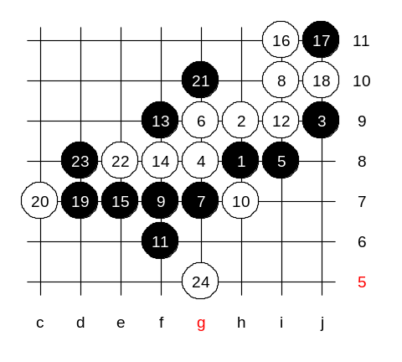
10th move, yes, basic rule – blocking the 3x3 point is usually the strongest defense. The old theory suggests 11-f9. But black was not so successful there. About 2-3 years ago, the first analyses of 11-f6 were made. It was actively disputed in Taiwan renju meetings 1-2 yeats ago. Black idea is very unusual here. 15-e7 is a very risky move. Japanese book comment 15-e7 to give white strong attack. Indeed, if you look at white’s possible VCF threats at i11 and i12, it sure looks scary. But at that time, the Japanese did not analyse the variants very deeply, and they probably just assumed that white advantage is enough for win. We will now take a look at possible white attack because defense is hopeless. The variants that we are about to check now are not written in any of the renju books yet. I was surprised that Japanese and Russians did not know about this variant before last WC.
White cannot take the j11 point itself, because that way white would not have VCF threat. So, black can always take i11. That makes the analysing simpler. Now, black has two control points – the j-line and g10 point that is linking down to black structures. These control points help to defend the white attack! How can white attack now?

Well, if you feel that black cannot win here, and there is no good positional outcome either, then we have just proved that black’s active defense was unnecessary.
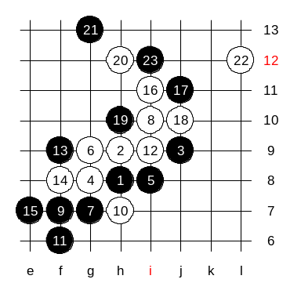
Therefore, we simply defend, and wait the failure of white attack. Simple h10 is the best answer. Now we just wait until black attack fails, and then white is unable to defend below, and black gets the desired win. If white plays h10 first, then black can surround whites in upper area , together with powerful left side support. But now, lets first check this variant. It is important. If black makes a smallest mistake here, white wins. Now we have two choices, to play 22-L12, or 22-i12, 24-L12. Black takes i12 if it is left empty. Ok, as you voted, we play L12. Now, if white does not take the k10 point, then black will. If you play white k10, but you leave k9 or k11 open then black goes there. All looks so hopeless for white here.

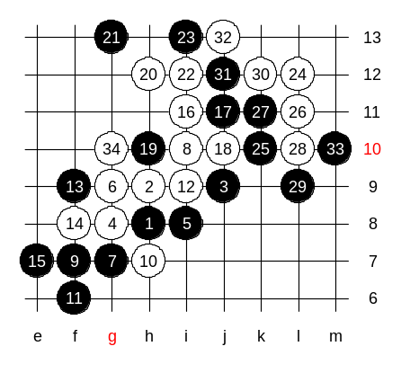
Ok, we try to use white i12 first. Here, the defense move according to my analysis is 25-k10. I cannot see any continuation for white attack. Move 26-L11 is the only interesting variant here. And now, as unbelievable as it seems, white does not have a sequence to win here. Buit white attack is long here. Can it win after all? I missed g10 in my first analyse 3 years ago. White seems to win though. Or, it needs closer look. Probably we might need to change something earlier.

We will continue this variant in our next week lesson.

